Unloop Full Stack Web Development

## JavaScript Lab 2: Mood Indicator!

Prior to completing this lab, watch the following videos:

1. What is JavaScript?
2. Data Types
3. Conditionals

## Learning Objectives:

By completing this lab you will get practice with the following JavaScript concepts:

* JavaScript variables
* Onclick() event
* Manipulating CSS styles with JavaScript
* Manipulating the image src attribute with JavaScript
* Basic function + parameter passing

Objective: Create a simple website that displays the user’s mood based on the image they select.

# Lab Instructions

**Step 1:** Create a basic HTML page. Fill in the <title> with the words “Mood Indicator App”

**Step 2:** Add an <h1> tag and label your website with the words “<Your Name’s> Mood Indicator!”

**Step 3:** Add the how-you-doing.png image to your site. Be sure to include a descriptive “alt” attribute value. Give this image the id of “moodImage” so that we can manipulate it using JavaScript later on.

**Step 4:** Create 3 buttons—one for each of our moods. Happy, Okay, and Sad.

**Step 5:** Create a JavaScript file under the js folder in your project. Name this file “script.js.” Link to this external script at the bottom of your HTML page. *(The location you link your external script is important here because we need to make sure all of our content has been render on the page prior to manipulating it with JavaScript.)*

**Step 6:** Now we will add some simple JS functionality onto our page using the [JavaScript onclick event](http://www.w3schools.com/js/js_events.html) to detect when each button is clicked. When each button is clicked, we want to call our function named changeMood(…). Add the onclick attribute to each button and call the changeMood function with the mood the user selected. I.e this is what the happy button’s code should look like:

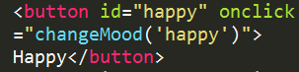

*Here we are passing in the String value “happy” to our function named “changeMood.” We will talk about functions more in depth in future classes.*

**Step 7:** Create the changeMood(…) function in your script file. This function will accept one “parameter.” Parameters allow us to pass information back and forth between our HTML and our JavaScript “layers” or in this case, files. Your empty function should look like the following:

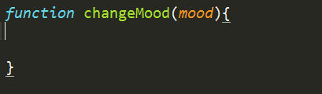

**Step 8:** Create your if-statements to check what mood the user is in. It should look something like this:

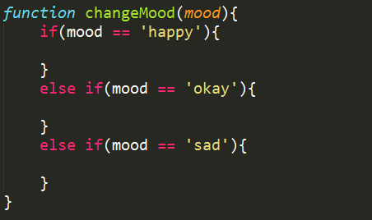

**Step 9:** Now, we are going to change the src value of our moodImage based on the user’s current mood. Your function should look something like this. Note the file paths are relative and live in a separate images folder. :

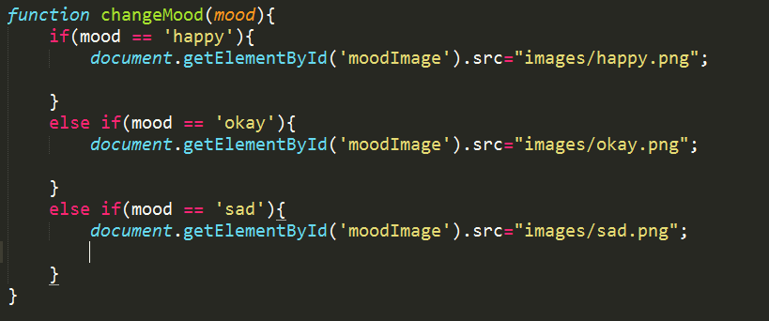

**Step 10:** Let’s add some pizzazz to our page! Now, we are going to practice [manipulating CSS properties using JavaScript](http://www.w3schools.com/js/js_htmldom_css.html). Here we will be manipulating the background color of our page. To manipulate CSS properties we use the “style” keyword. *Pro Tip: In JavaScript, all CSS properties are camel cased with no dash in-between their words. i.e. backgroundColor, fontSize, borderBottom, etc. A full listing of the properties we can select is* [*here*](http://www.w3schools.com/jsref/dom_obj_style.html)*.* Your function should now look something like this:

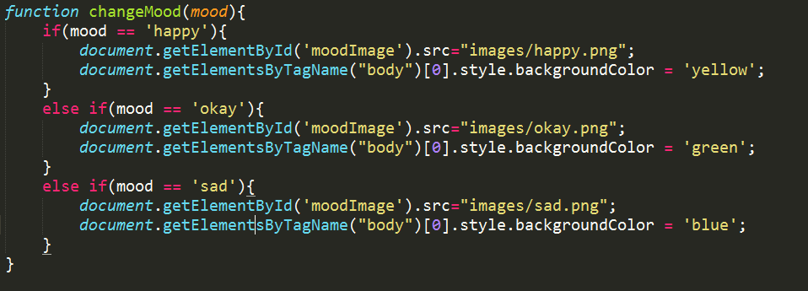

**Step 11:** Test your page. When each button is clicked, the images should change to the user’s respective mood. The color of your page should change along with it.

Check that you have no JavaScript errors by Inspecting your page in Google Developer Tools. If there is an error, you will see a little red circle with an X in the upper right hand corner.

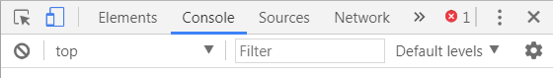

**Step 12** (Challenge): Add today’s date to your web page. Use the JavaScript Date Object. You may choose a Date formatting of your choice. See examples in the documentation below.

[Date Object Documentation Here](http://www.w3schools.com/js/js_dates.html)

# Final Product Screenshots:

